Wilson Quilli and Jason O’Neill

Professor Janghoon Yang

CMPSC 132

April 12th, 2024

***Election Management System Report***

***Description of Project:***

Our project is a comprehensive election management system designed to automate voting process administration through a software solution. The code comprises several classes that include, ‘Voter’, ‘Candidate’, and ‘Admin’, each that poses different roles within the election system. This system allows for handling various tasks such as voter and candidate registration, vote casting, and the tallying of results. The data persistence is achieved through a CSV file, which allows the system to maintain state across sessions. Users can interact with the system through two different menus: one for admin accounts and the other for voter accounts, each offering role-specific functions.

In detail, the admin menu permits the election administrator to add or remove voters and candidates, access results to the election, and manage administrative data, secured by an admin key that must be entered during sign-ups to gain authorization. On the other hand, the voter menu allows voters to view details about the candidates like the party they are with and their goals, cast and modify their votes, and provide feedback on the whole election process. This process of two menus ensures that the admins' and voters' interactions are handled efficiently while maintaining the integrity and confidentiality of voting. Additionally, the system is capable of saving and loading data from CSV files, to help manage large amounts of data and ensure data recovery and storage capabilities.

***Project Goals:***

We created this Election Management System with multiple goals in our minds while developing it. For example, our first goal with our management system was that our users could log in and sign up successfully with two required fields both being the admin key for admins and the age for voters, having to be older than 18. We wanted to implement in our system, a user-friendly login and signup process for both admins and voters, with specific requirements such as the admin key and age requirement, to be able to do that. Furthermore, another goal we had was to create a good storage system, using the CSV Files for saved data for all users. We wanted to implement a reliable storage system and we did that by using CSV Files, so they can store any user data efficiently. Additionally, another goal we had was to hear from any feedback, so we can improve our system in any way. We wanted to implement a feedback process to gather any user input and suggestions, on any way we can improve our system for things like glitches and address any concerns a user may have. Finally, the main goal we had in creating this project, was to make a very easy-to-use system for all users and not make it too complicated to use, so everyone can use it, all you have to do is create an account, log in with that account, and choose the number of the action you want to commit. We wanted to implement an accessible user interface and make it as easy to use and user-friendly as possible; and allow users to navigate through the system easily and without any problems.

***Significance of the Project:***

The significance of our project is how easy it is to use and the methods we use throughout the code. We used CSV Files in our system for storage, and we used it because of its efficiency and ease of use. Utilizing CSV Files, allows our program’s storage system to be simple, efficient, and gets the job done and ensures good data management in our election management system. In our code, we also used three different classes; Voter, Admin, and Candidate to store all of our attributes in each class for example their usernames and passwords, making it very easy to read and visualize the code. We also used error handling to prevent any errors from occurring when an input is inputted incorrectly and will just let you try again; this allows the user to have a struggle-free or without any complications experience when using our system. Overall, the significance of our project is the code throughout with its organized methods and functions, a good visualization of the organized code since it’s all it’s Classes contain attributes and how easy it is for our users to use while having the important features such as voting for a candidate, and instead of typing a keyword or method to act, you just have to input the number next to the action, you want to commit. In the end, the significance of our Election Management System, is how organized the code it contains is, the usage of CSV Files for a simple, efficient storage system, error handling to prevent any errors to occur when users input a wrong input, and how it’s built with the main goal to be user-friendly and easy to use, perfect for managing elections and by prioritizing a user-friendly system, our project directly address the complexities and difficulties that are usually associated with election management and administration, ultimately contributing to improving the election process for everyone, both admins and voters.

***Installation and Usage Instructions:***

**Installation:**

To install our Election Management System, first, you have to make sure you have Python downloaded on your computer, as our program was created with Python and on PyCharm. Secondly, you have to download the code and save it as a Python file, in my test, I named it election_system.py. Thirdly, I opened Terminal on my Mac and used the cd command to open the file election_system.py from my downloads folder on My Mac. After pulling up the code on Terminal, you have to input python3 election_system.py to be able to run the program/system. After running the program, you just perform the required actions; so signing up as either an admin (with the key: WJES) or a voter (18 or older) and then logging in after creating your account. After logging in, you just go on from there choosing the actions you wish to perform on the menus and after you’re done, you just exit the program from the main menu.

**Usage Instructions:**

**Getting Started**

**Run the Program:**

* Save the code to a file named election_system.py.
* Open your terminal or command prompt.
* Navigate to the directory where you saved election_system.py.
* Run the command: python election_system.py.

**Features**

* Admin Functions: Login or sign up, manage voter and candidate lists, view and analyze election results, and handle feedback.
* Voter Functions: Register, log in, vote for candidates, modify votes, view election status, and provide feedback.

**Usage Tips**

* Admins need an admin key to sign up.
* Voters must be 18 or older to register.
* Exiting: Choose the 'Exit System' option in the menu to close the application.

**Data Handling**

* Save and Load Data: The system automatically loads existing data at startup and provides options to save changes to CSV files.

***Possible Functionalities:***

As shown in the title, the functionality of our election management system is to help people run elections and manage them. Our system allows admins to manage an election and perform actions such as declaring the winner of the election removing any candidate that has backed out of the election race and more. Our system also allows voters to vote, view and search candidates, see the election's current status, and more. Overall, our Election Management System was made to help manage and run Elections for an Electoral Race, when it comes to voting for senators or president, including all the fundamentals of an election, and easy to use for both admins and voters. Ultimately, our Election Management System’s possible functionalities is to help people run elections and manage them, but not just presidential elections, any election. Our system contains all the necessary and important components of an election and it’s designed to be able to meet all the needs of both admins and voters when it comes to Election; and also being efficient and easy to use, makes for a better experience for all parties in an Election.

***Structure of the Code:***

In the design of our election management system, we decided to structure the code around the principles of OOP. This is exemplified through the creation of different classes: ‘Voter’, ‘Candidate’, ‘Admin’, and ‘Election, each being tailored to handle and do specific functions within the system. The ‘Voter’ class encapsulates all functionalities and attributes that are relevant to individual voters, such as their name, voter ID, age, voter data, and feedback, which ensures that personal data is being secured and managed well. The ‘Candidate’ class manages information such as their names, the party they are running with, and their goals if they win, establishing a way for voters to make their decisions. Similarly, the ‘Admin’ class is designed for system admins, that can take on administrative tasks such as managing voter and candidate lists, and overseeing election statistics with enhanced security and efficiency.

At the core of the system is the ‘Election’ class, this is what controls the overall election management by coordinating the interactions between voters and administrators. It manages comprehensive lists of these entities and provides functionalities that include adding, removing, and searching within these lists. Furthermore, this class is what oversees the voting process, collects feedback, and complies with results from the election. Integrating CSV file operations within this class allows for efficient data storage and retrieval. This design supports system functionalities while making a foundation for enhancements to be made in the future. Overall, the system’s structure is designed to ensure security, efficient management of election processes, and scalability.

***Diagram/Flow Chart of the Code:***

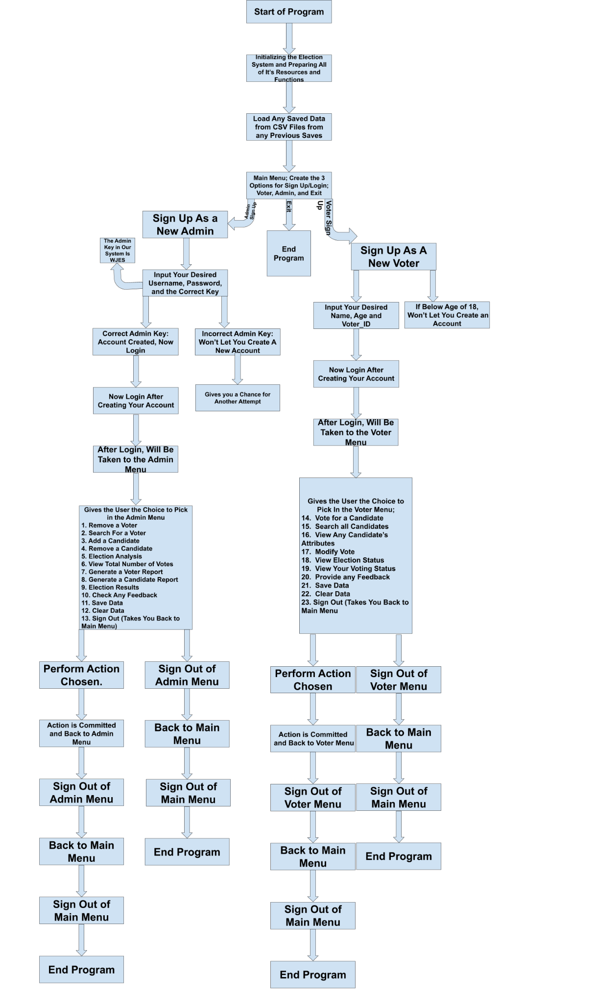

***Comments on the Flow Chart/Diagram:***

In the flow chart, you first start with viewing the main menu shown to everyone, following initialization and loading any saved data from CSV Files. On the main menu, you will be granted five different options. The first is to sign up as a new admin, this will lead you to create a username, password, and the correct Admin Key to the system (WJES). An incorrect Admin Key input, won’t let you create an admin key until it is inputted correctly. After that, you will be taken back to the main menu and you can log in from there inputting the username and password you created; choosing the second option. The third is to sign up as a new voter, this will lead you to input your name, Voter_ID, and your age. If the new voter is below the age of 18 (the age required to vote), they won’t be able to create a new account, if they are, they will be taken back to the main menu and choose option 4, which will ask you to login using the voter information, you just created. The fifth and last option ends the program. After logging in on in the admin menu, you will be greeted by the admin menu, which has many choices to choose from. These choices range from choosing to remove a voter to adding a new candidate and more. The program will run the action you chose, and then take you back to the admin menu where you can either choose to commit another action or just sign out of the program. On the other side of the flow chart, you will view the voter menu and also pick from a wide range of choices such as voting for a candidate viewing the current status of the election, and much more. Similar to the admin menu, the program will commit the chosen action and then you can choose to either choose another action or sign out of the program. After signing out, from either menu, you will be taken back to the main menu, where you can just click option 5 and exit the program completely. Overall, our flow chart showcases how the program runs and how it goes through each different action and it’s very user-friendly with the intention that anyone can use it by just clicking a number of the action they desire.

***Instructions on How to Use:***

**Run the Program:**

Simply start up the program.

**Sign Up:**

For Admins: Create a Username and Password, but you have to input the correct admin key to successfully create the account.

For Voters: Create a Name and Voter ID, and input your age, if you're below the age of 18, you won’t be able to create a new account, if you are, it will be successfully created.

**Log In:**

At the startup screen, choose to log in either as an Administrator or a Voter:

For Administrators: Choose "Admin login", then enter your username and password.

For Voters: Choose "Voter Log In", then enter your name and voter ID.

**Use the Menu:**

Once logged in, a menu will appear. Select any action by typing the number next to it:

Administrators can manage voters and candidates, check election results, etc.

Voters can vote, view candidate information, give feedback, etc.

**Save Changes:**

After making changes you want to keep, like adding voters or casting votes, choose "Save Data" from the menu to save everything to the CSV files.

**Exit:**

When done, go back to the main menu select the exit option to close the program, and log out.

***Verification of the Code’s Sanity***

After creating all the code and finishing the system, we conducted multiple tests to ensure the code’s sanity and make sure everything worked as intended throughout the entire system. I have to go over every line of code to ensure that it works as intended and to verify its sanity. After checking and testing the code, we can say that our Library Management System "gets the job done" and operates efficiently. Our system is also very easy to use, without any complications, where you just have to input a number in the menus. In our election management system, every class, method, and function that we use across the code performs its intended role. We added error handling using Try and Except to our system to prevent errors when anything is entered incorrectly. For our storage system, we used CSV Files to store any data, someone might want to save/store. We also added an authentication system, so not everybody can sign up as an admin utilizing an admin key function. The code has proven through extensive testing and validation that it can efficiently support voter registration, candidate management, voting, feedback reporting, data storage, and analysis of election results. Overall, the Election System code has been confirmed to effectively work for its intended purpose and this can also be proven in different sections of our report, in the sections of screenshots of our code in action and tests ran on the code. The code’s sanity can also be verified in the next section lablled Screenshot and Scenarios of the Program in Action.

***Screenshots and Scenarios of the Program in Action:***

***Scenario #1 - Signing Up (Admin): 1st Picture is the Correct Admin Key and 2nd Picture is the Incorrect Admin Key***

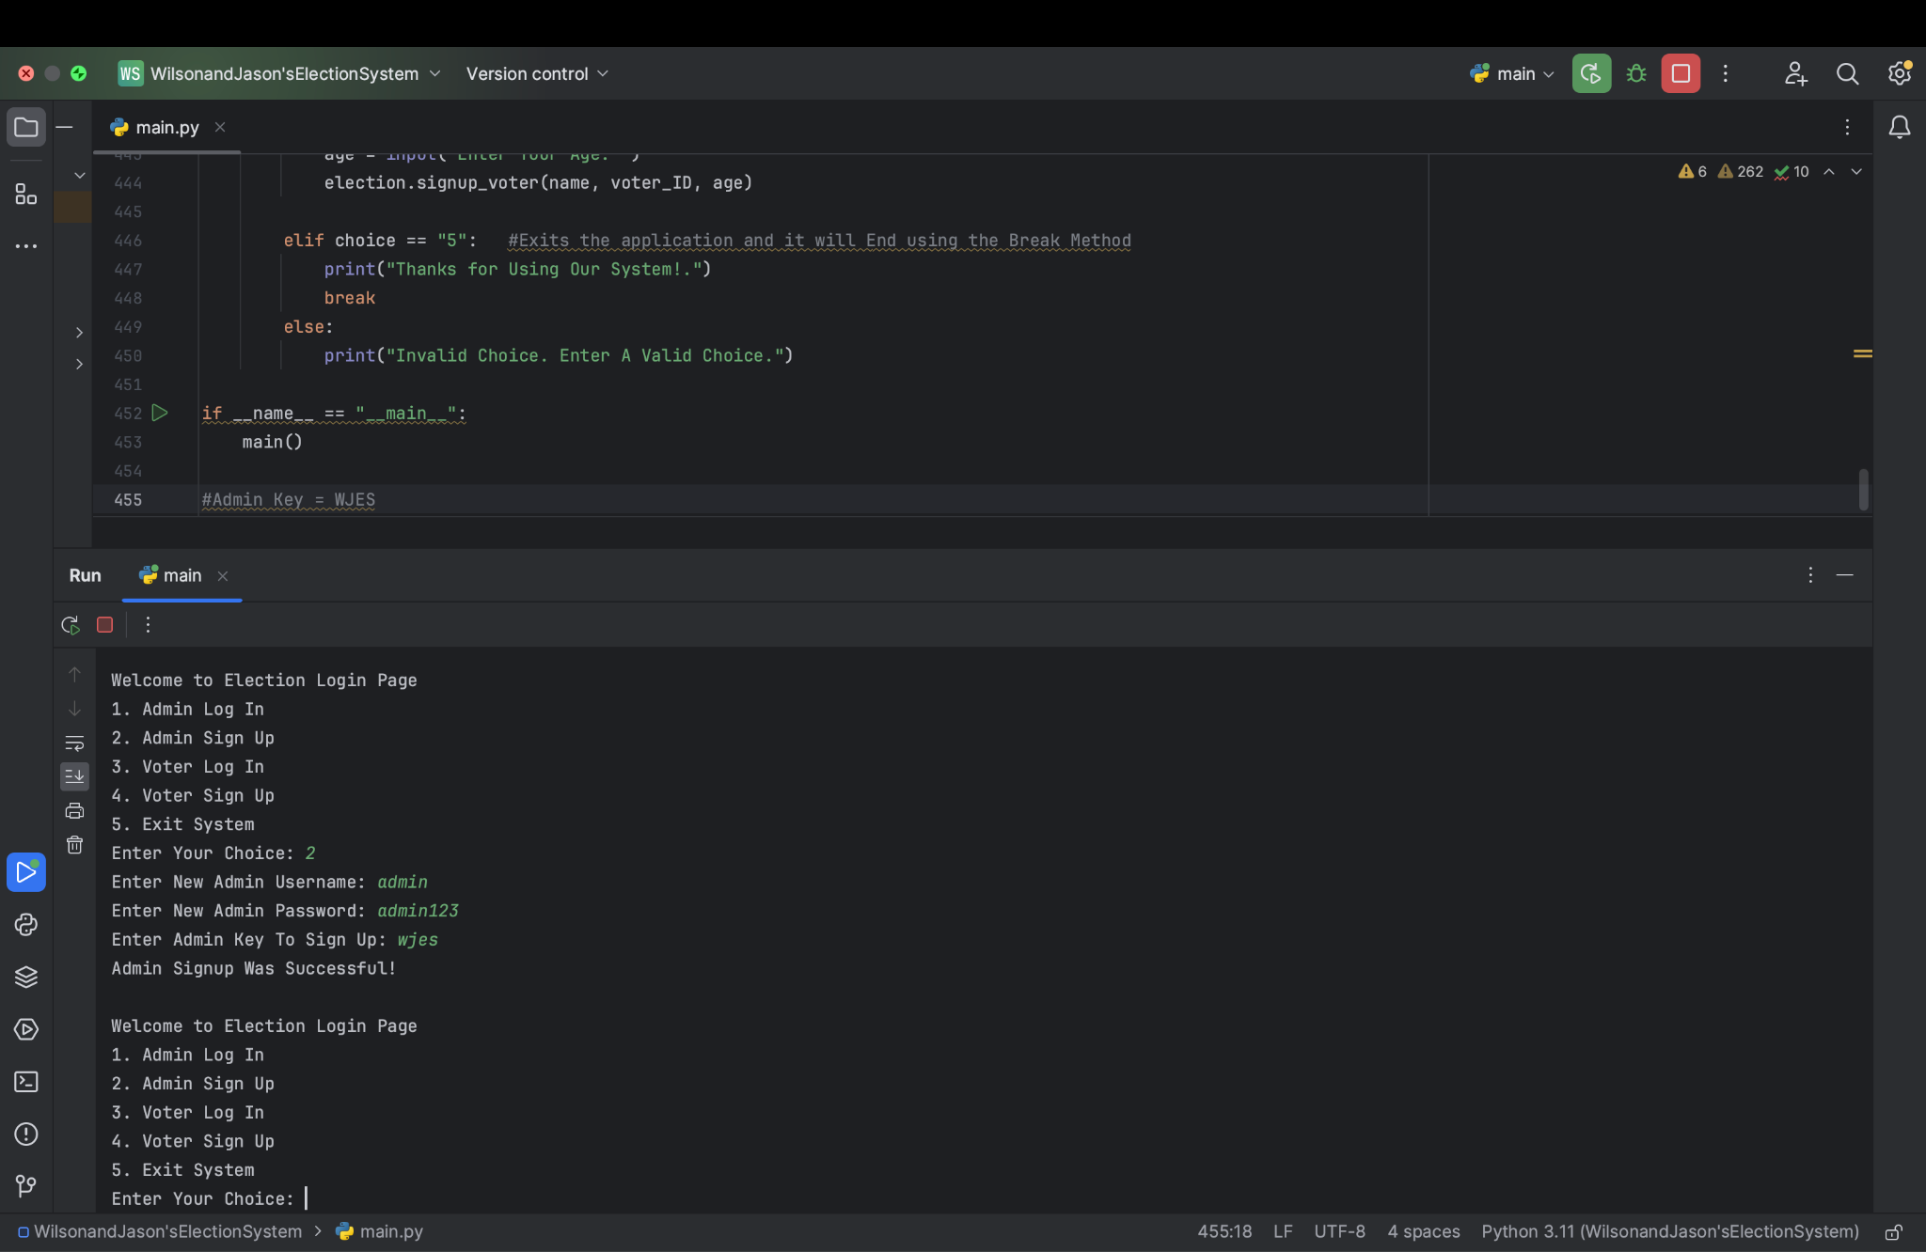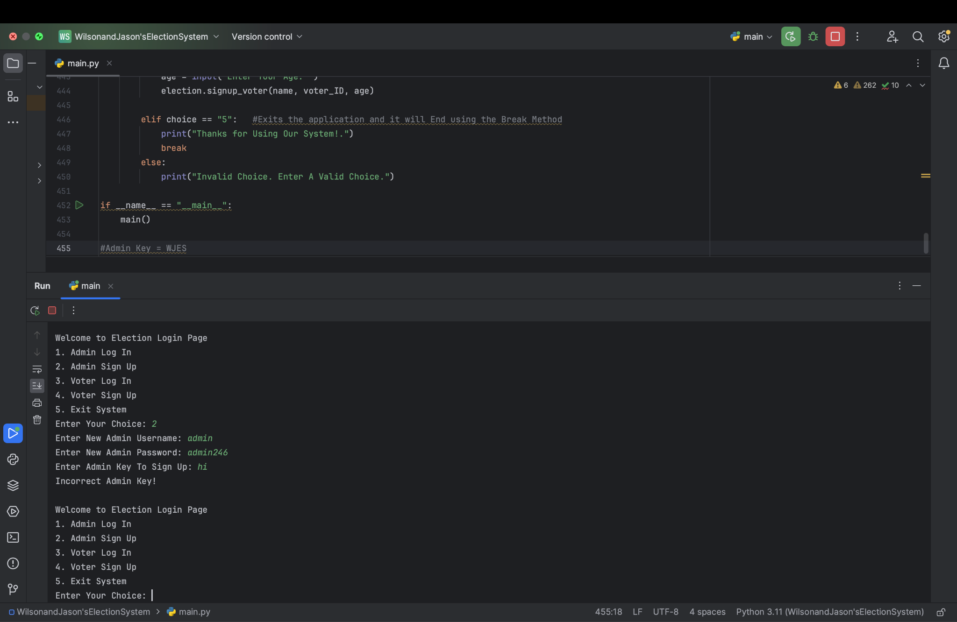

***Scenario #2 - Inputting Correct and Incorrect Login Information: 1st Picture is Correct Login and 2nd Picture is Incorrect Login (Admin)***

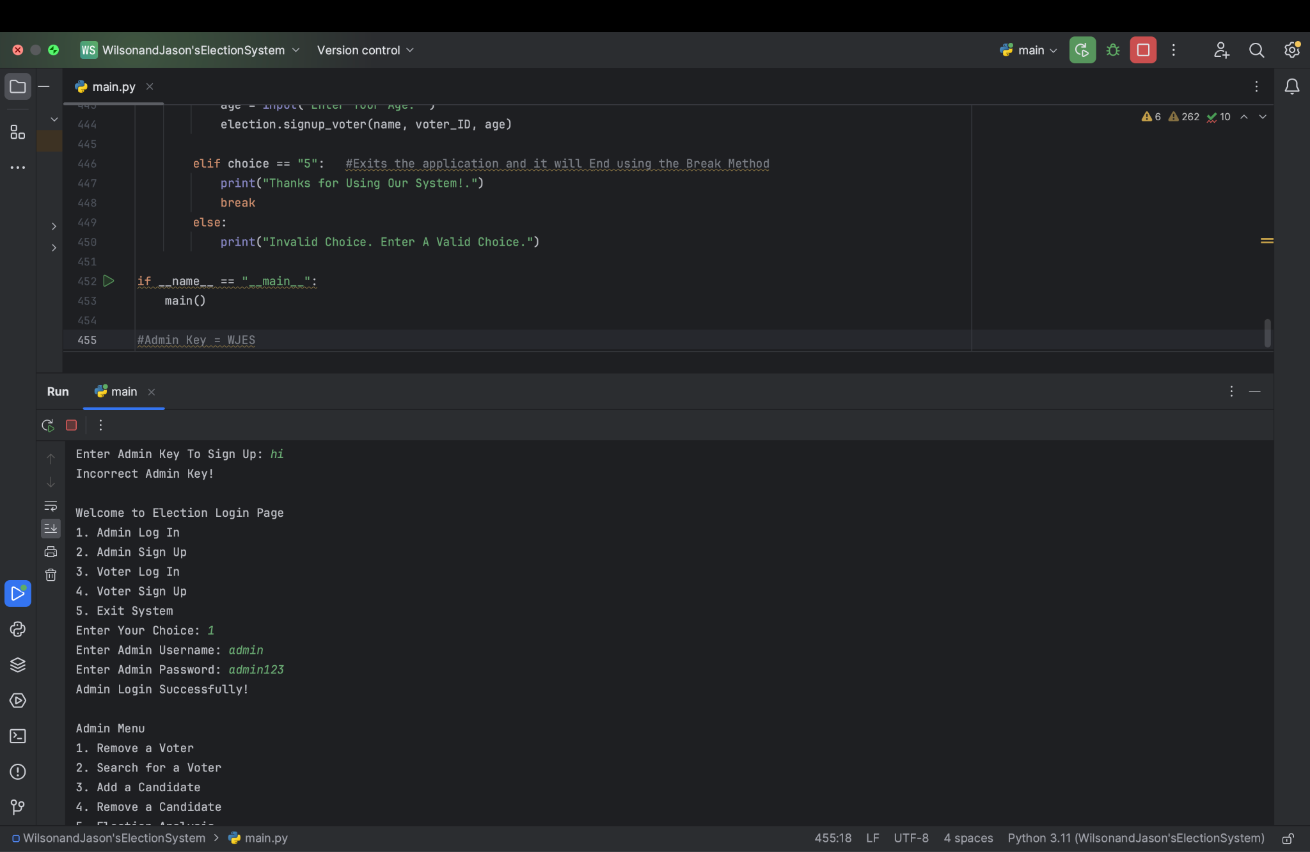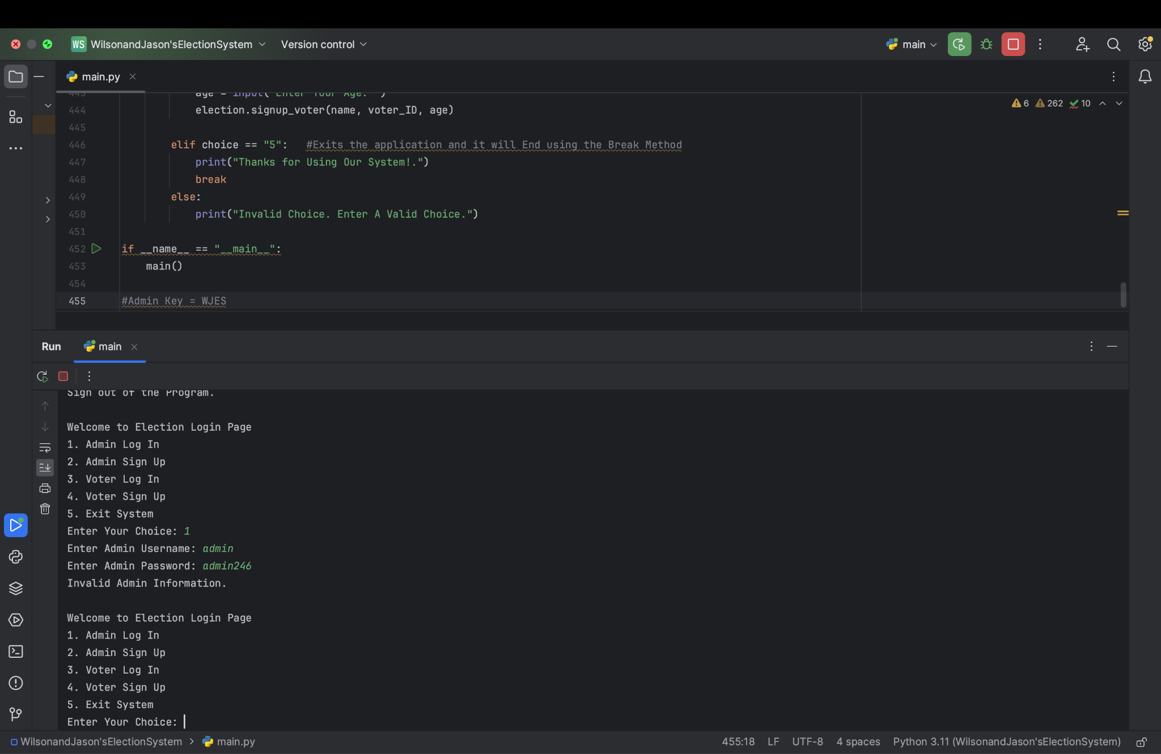

***Scenario #3 - Signing Up (Voter): 1st Picture is the Sufficient Age and 2nd Picture is an Insufficient Age***

***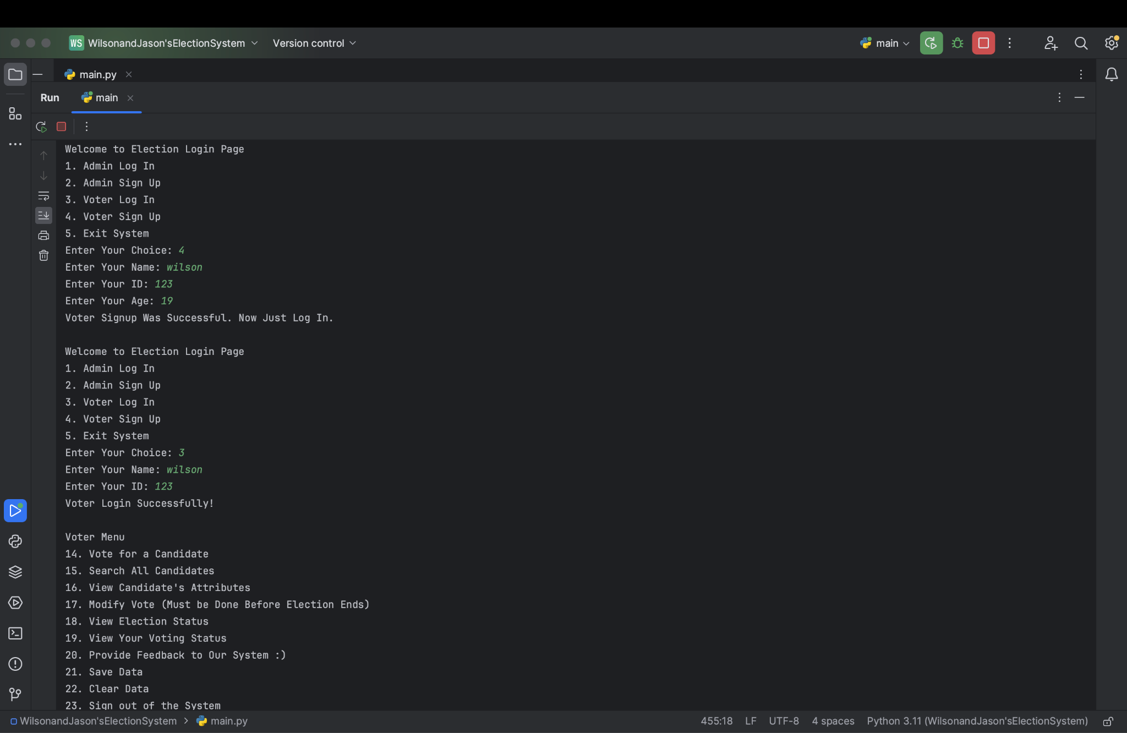* *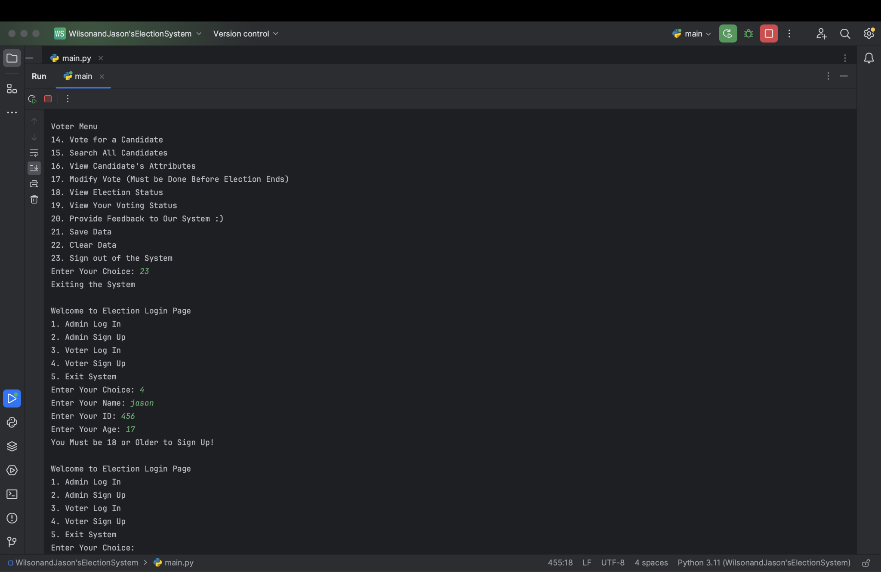***

***Scenario #4 - Inputting Correct and Incorrect Login Information: 1st Picture is Correct Login and 2nd Picture is Incorrect Login (Voter)***

 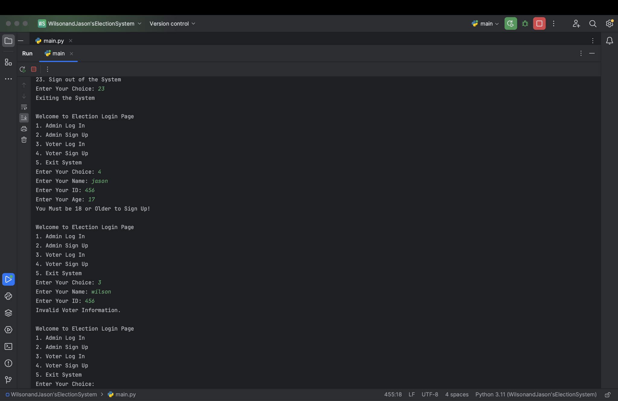

***Scenario #5 - Adding a Candidate (Admin)***

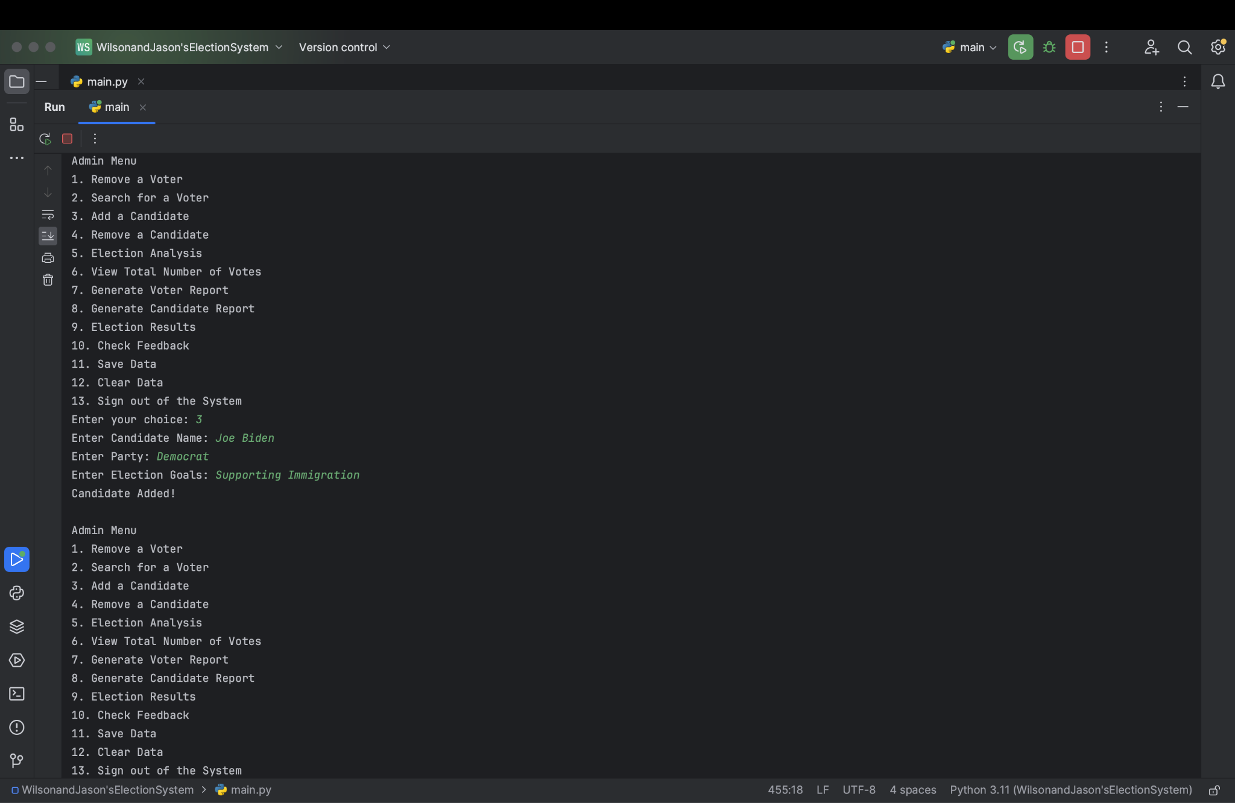

***Scenario #6 - Generating Both Voter and Candidate Reports (Admin)***

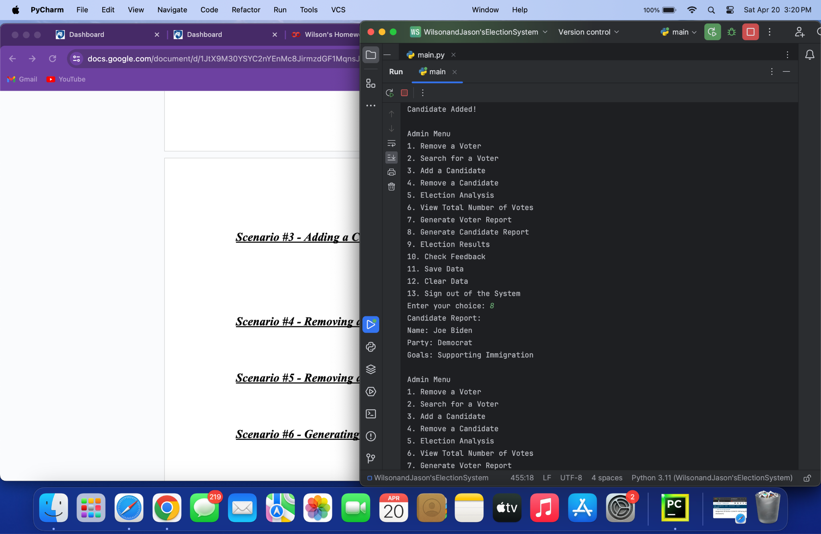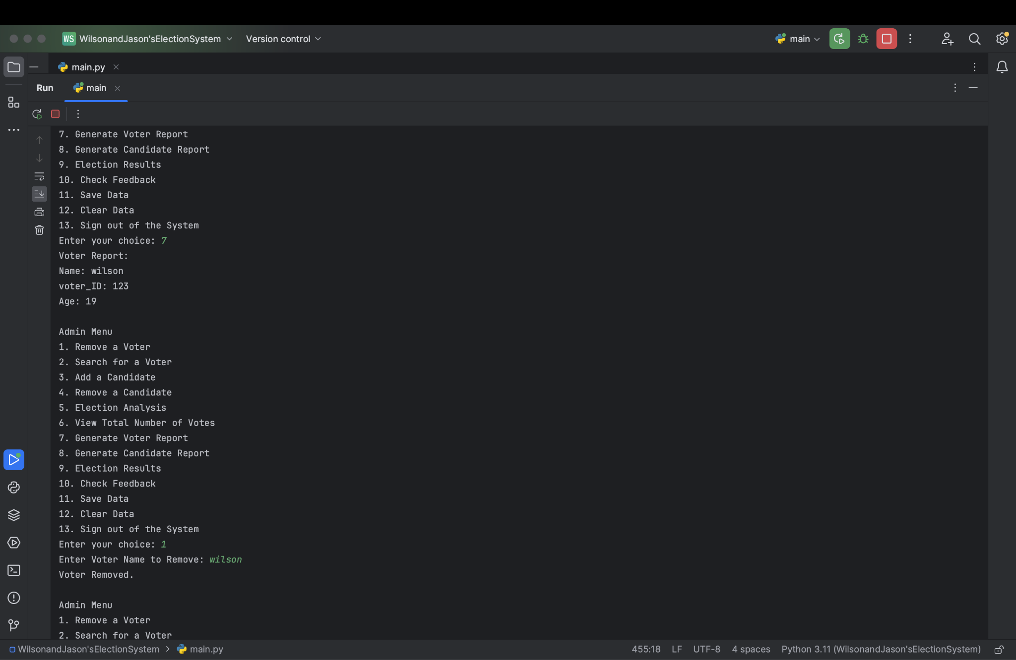

***Scenario #7 - Removing a Candidate (Admin)***

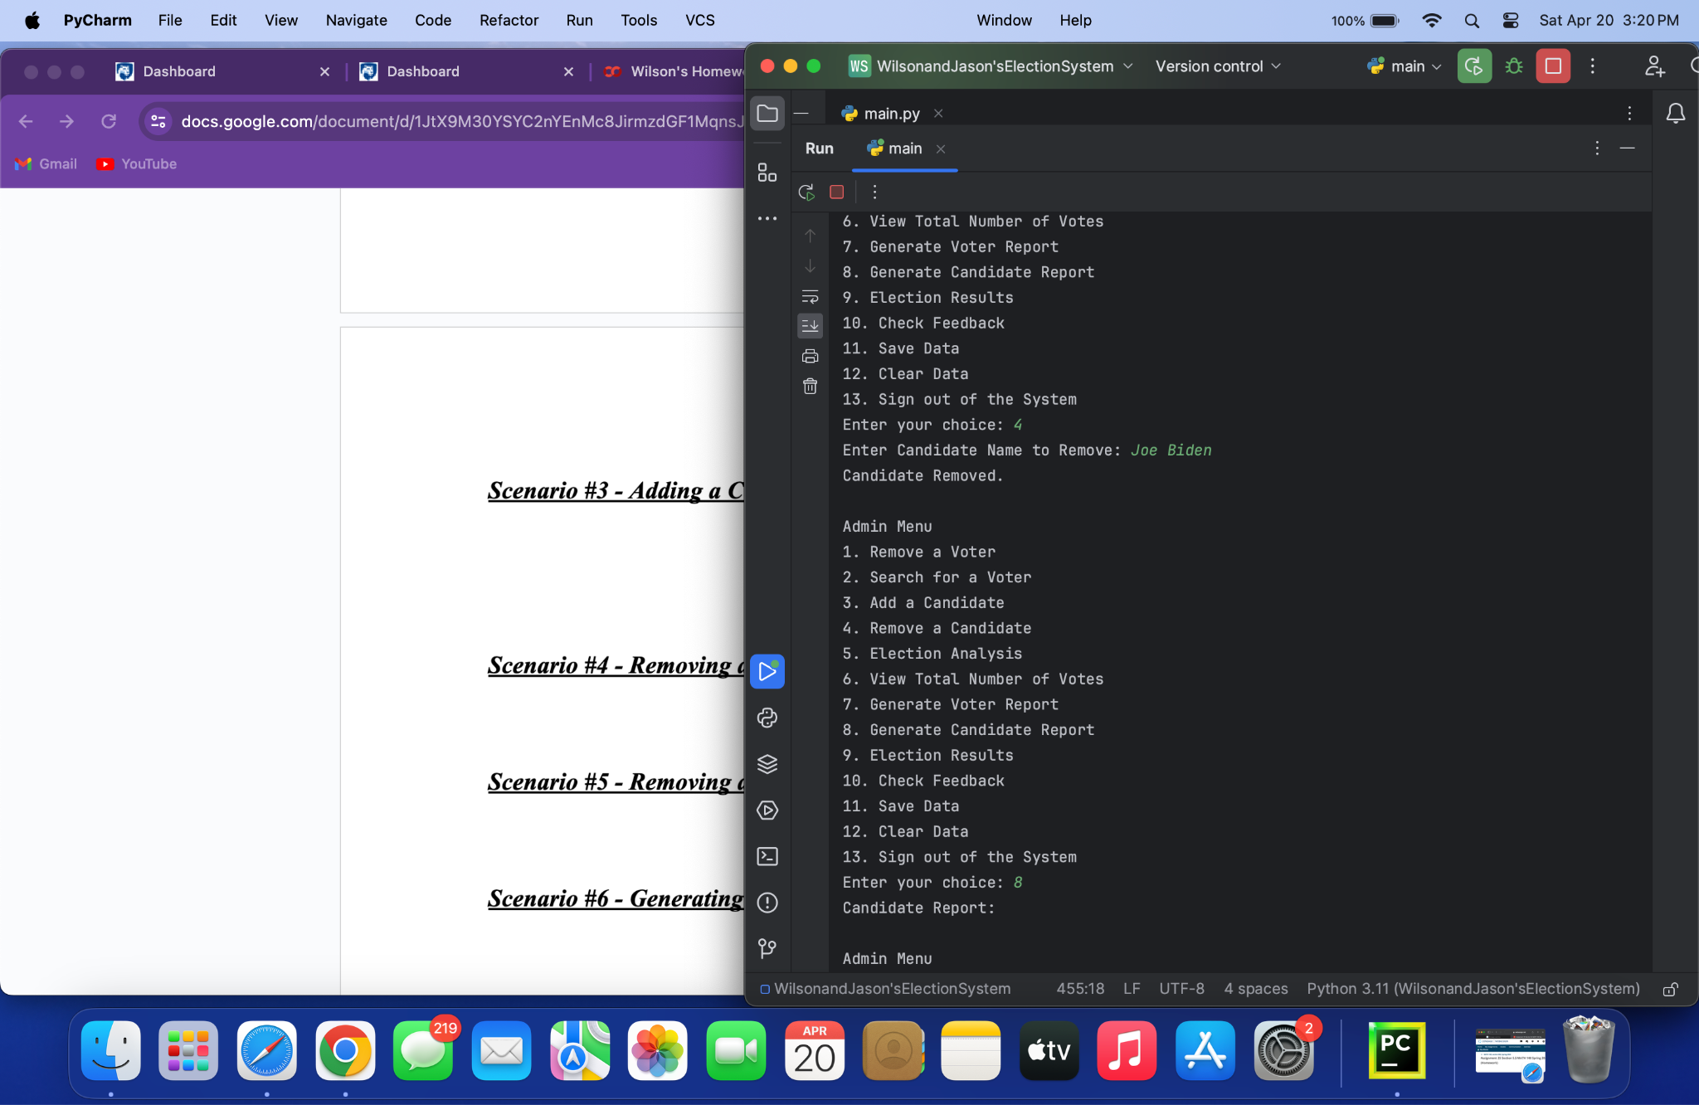

***Scenario #6 - Removing a Voter (Admin)***



***Scenario #7 - Search Candidates (Voter)***

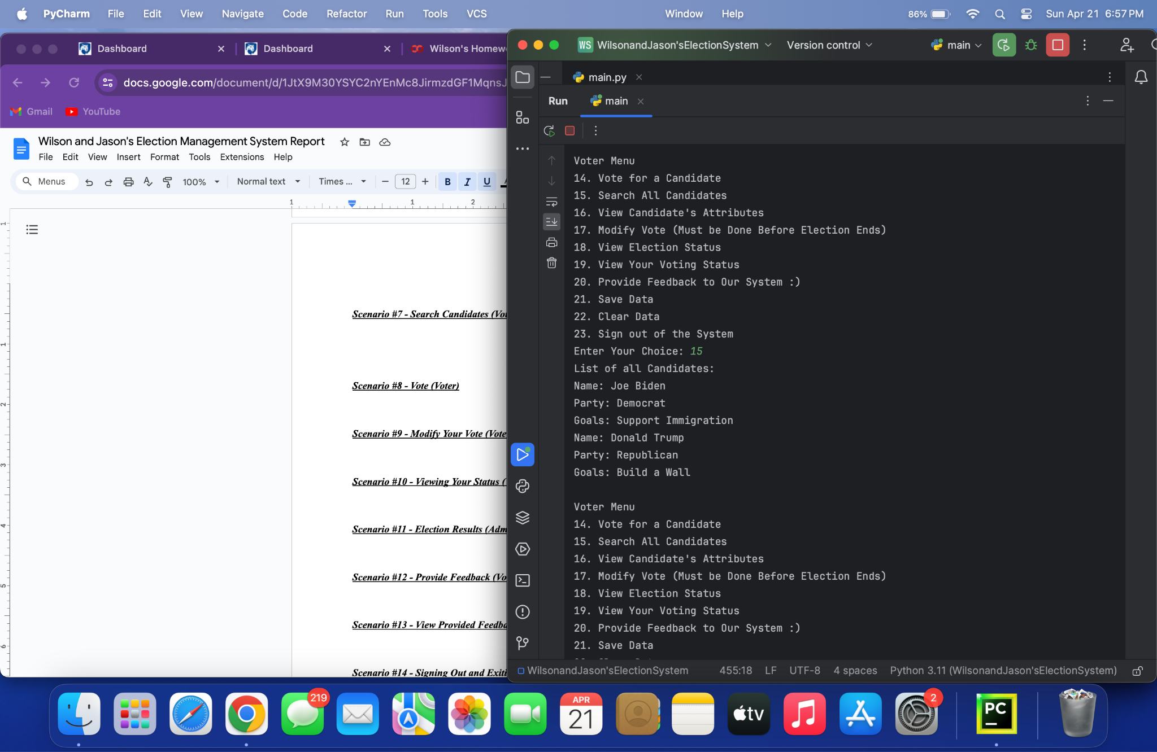

***Scenario #8 - Vote (Voter)***

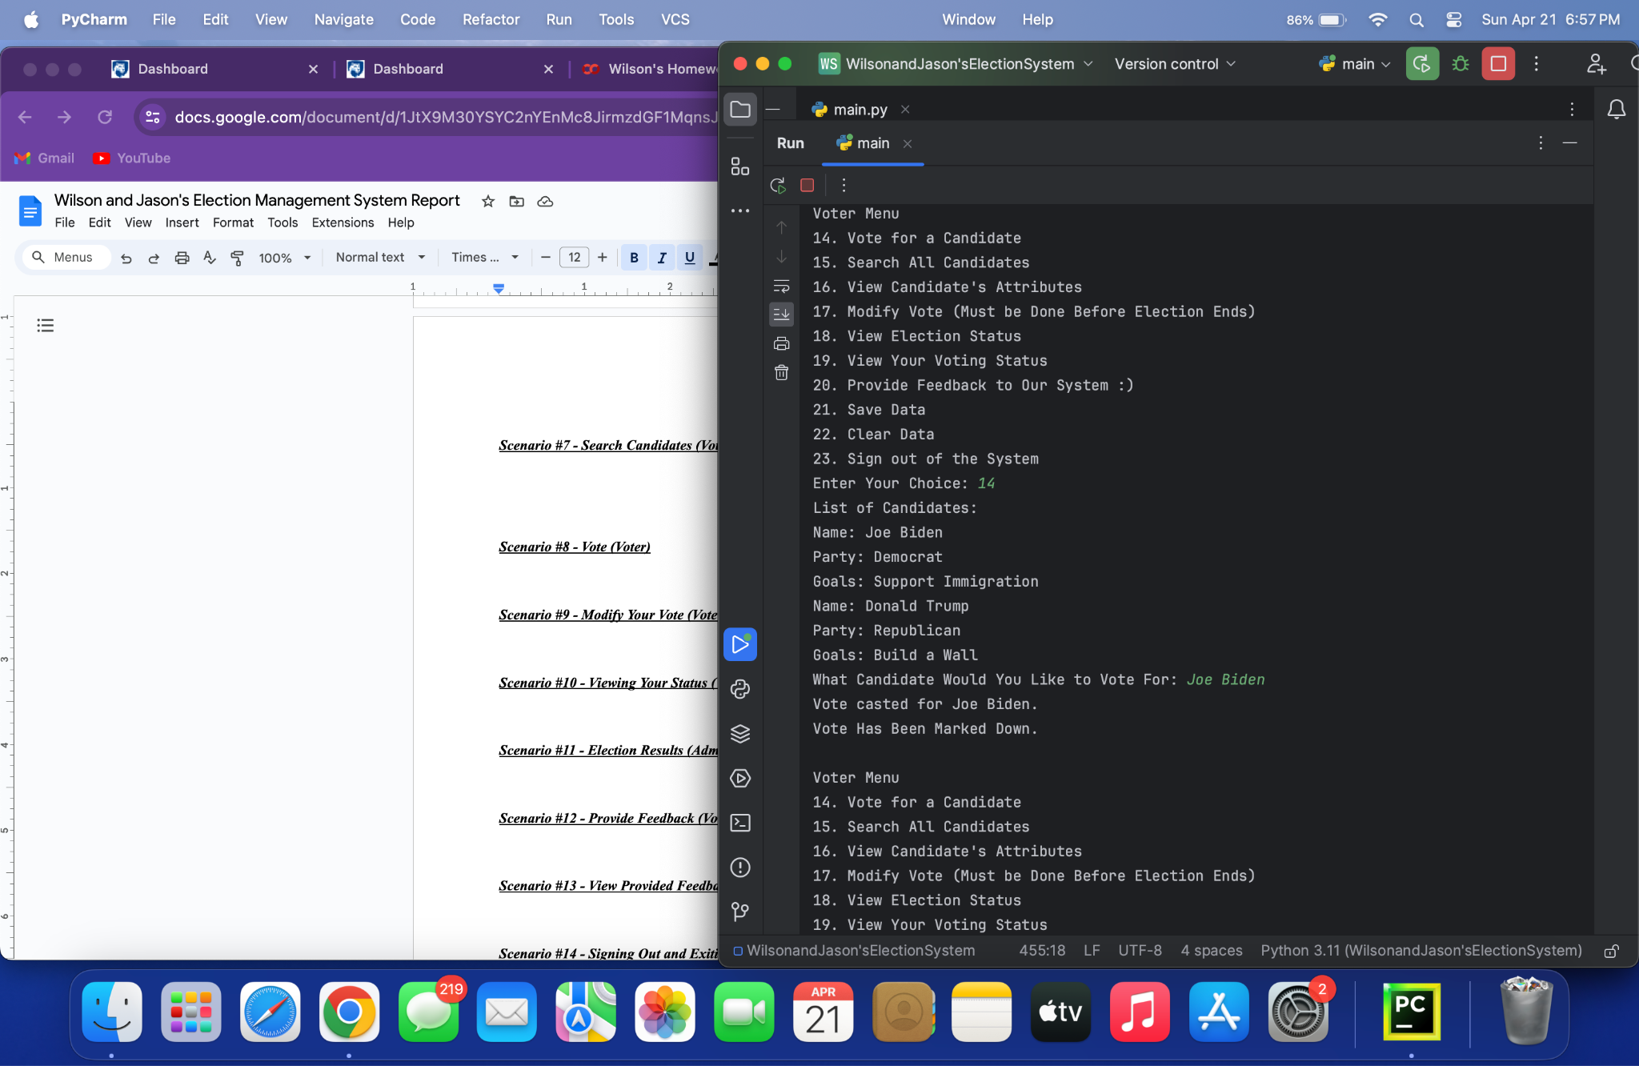

***Scenario #9 - Modify Your Vote (Voter)***

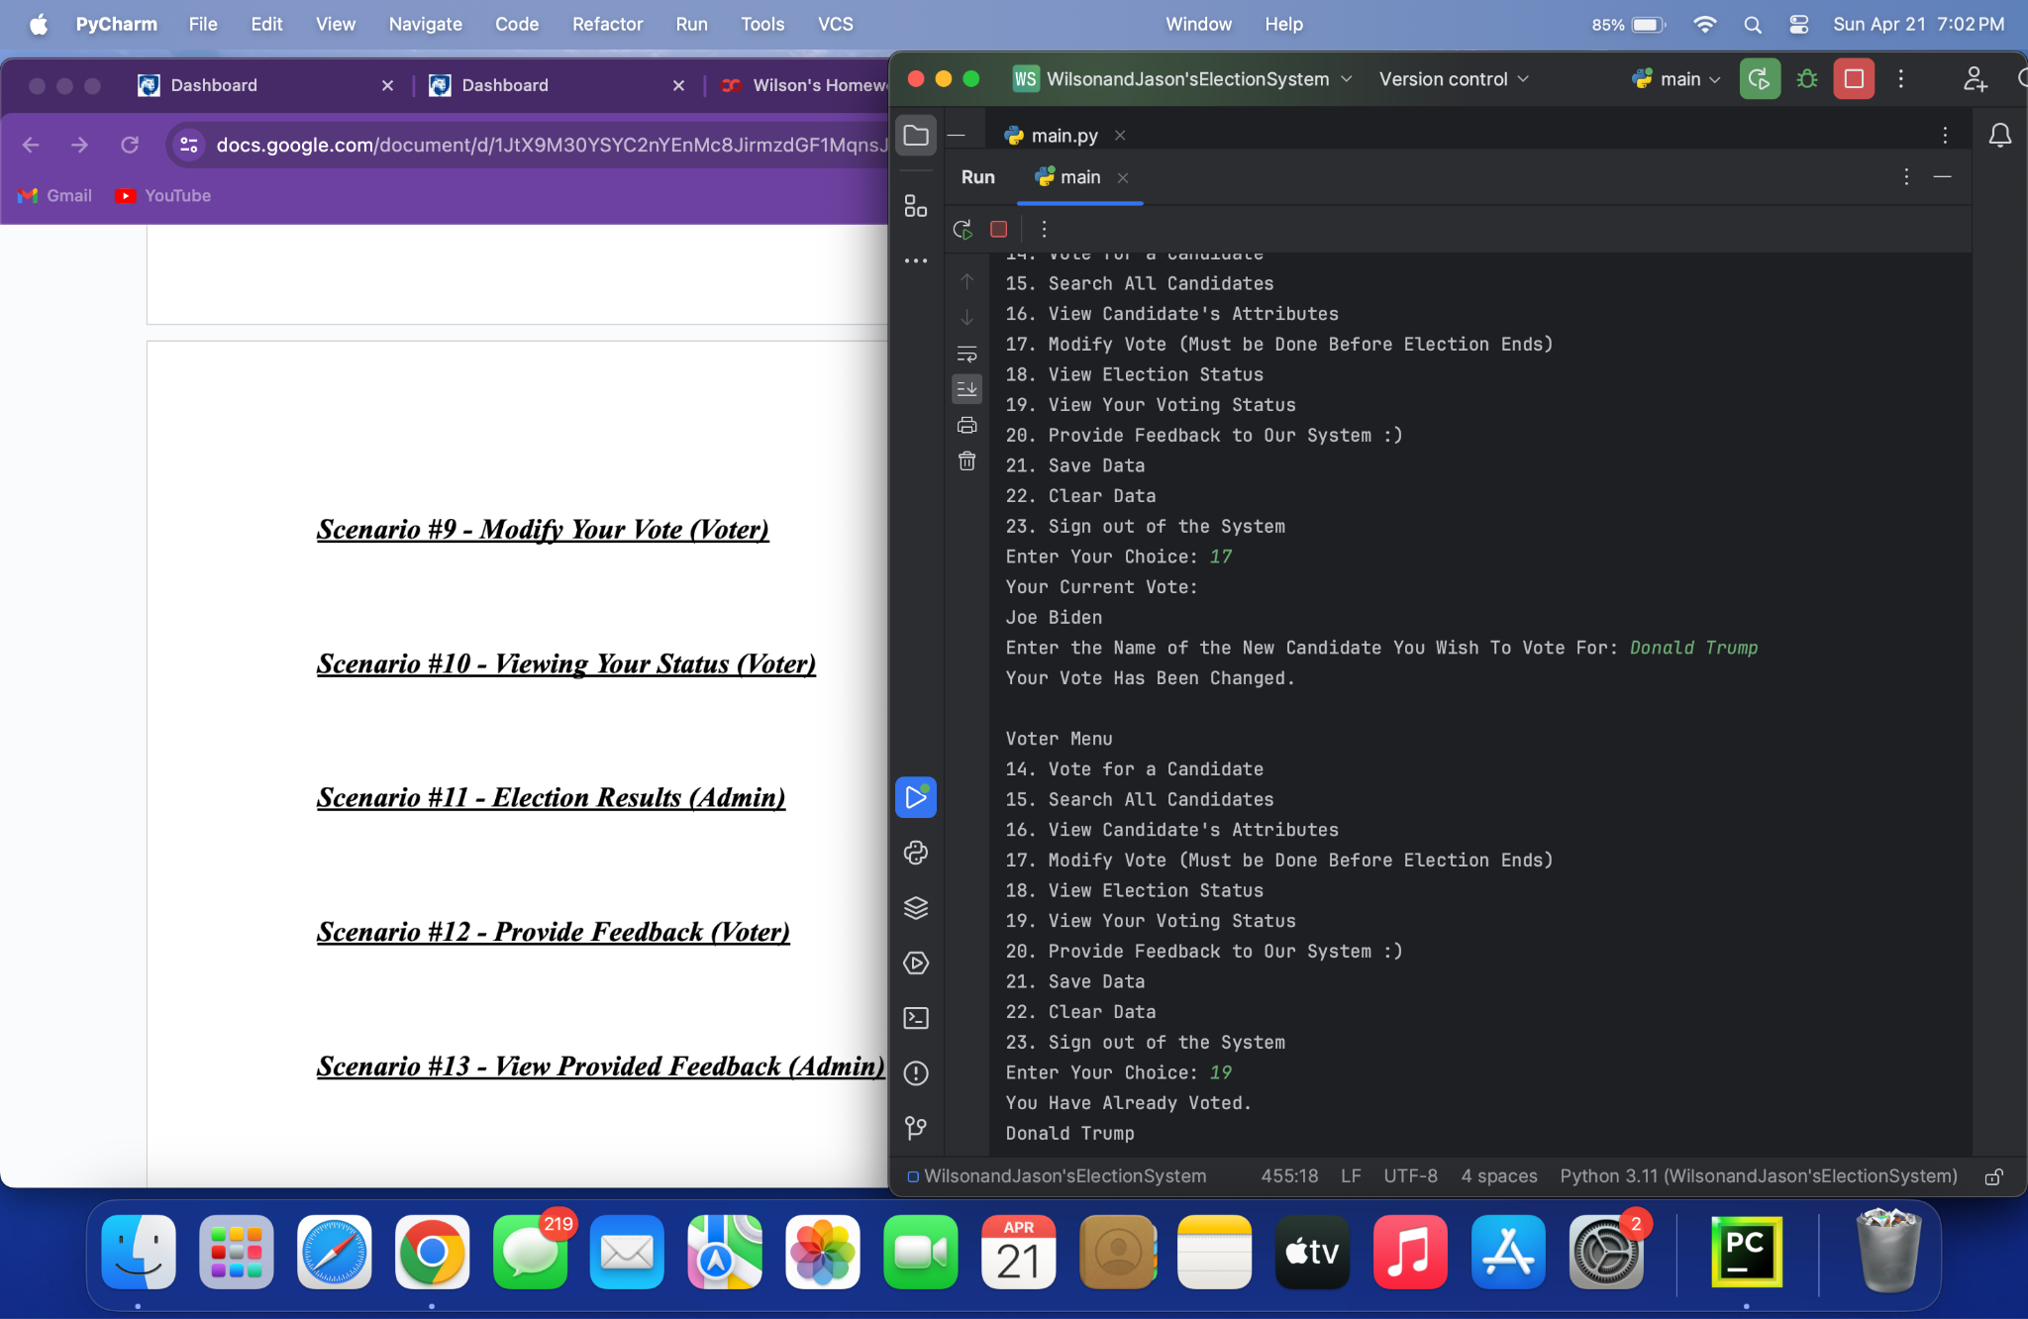

***Scenario #10 - Viewing Your Status (Voter)***



***Scenario #11 - Election Results (Admin)***

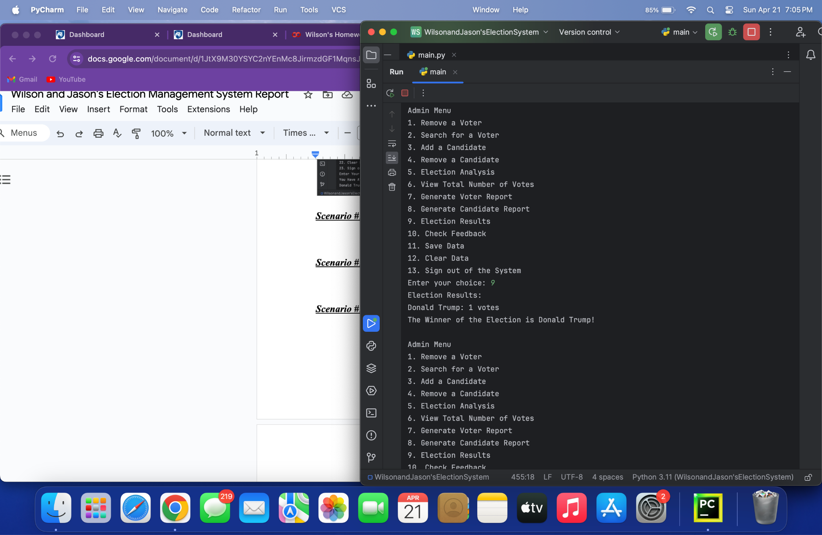

***Scenario #12 - Provide Feedback (Voter)***

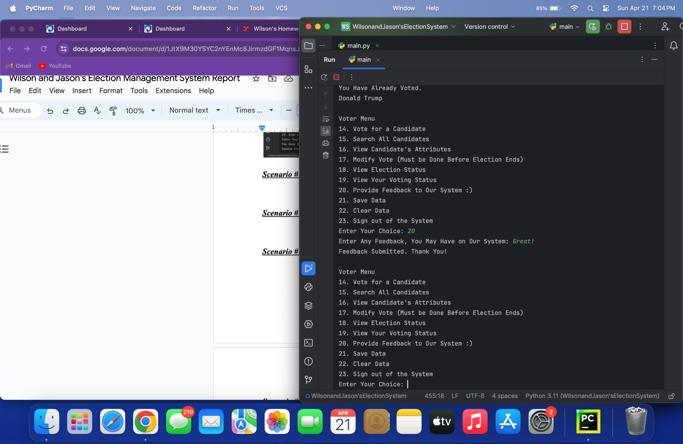

***Scenario #13 - View Provided Feedback (Admin)***

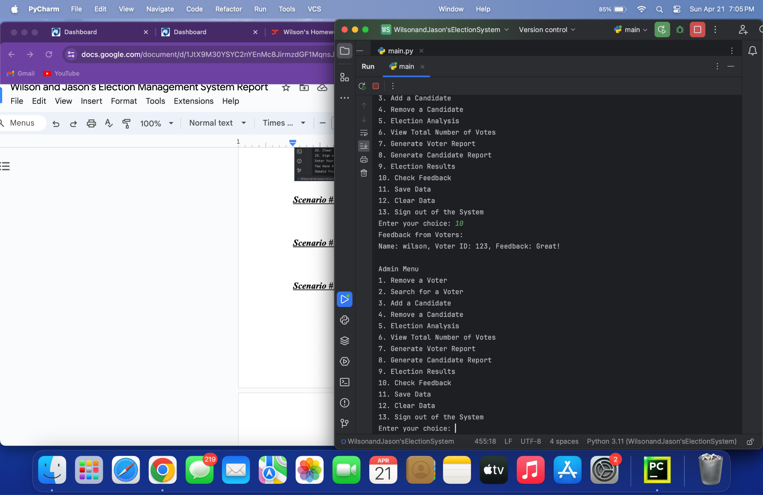

***Scenario #14 - Signing Out and Exiting the Program***

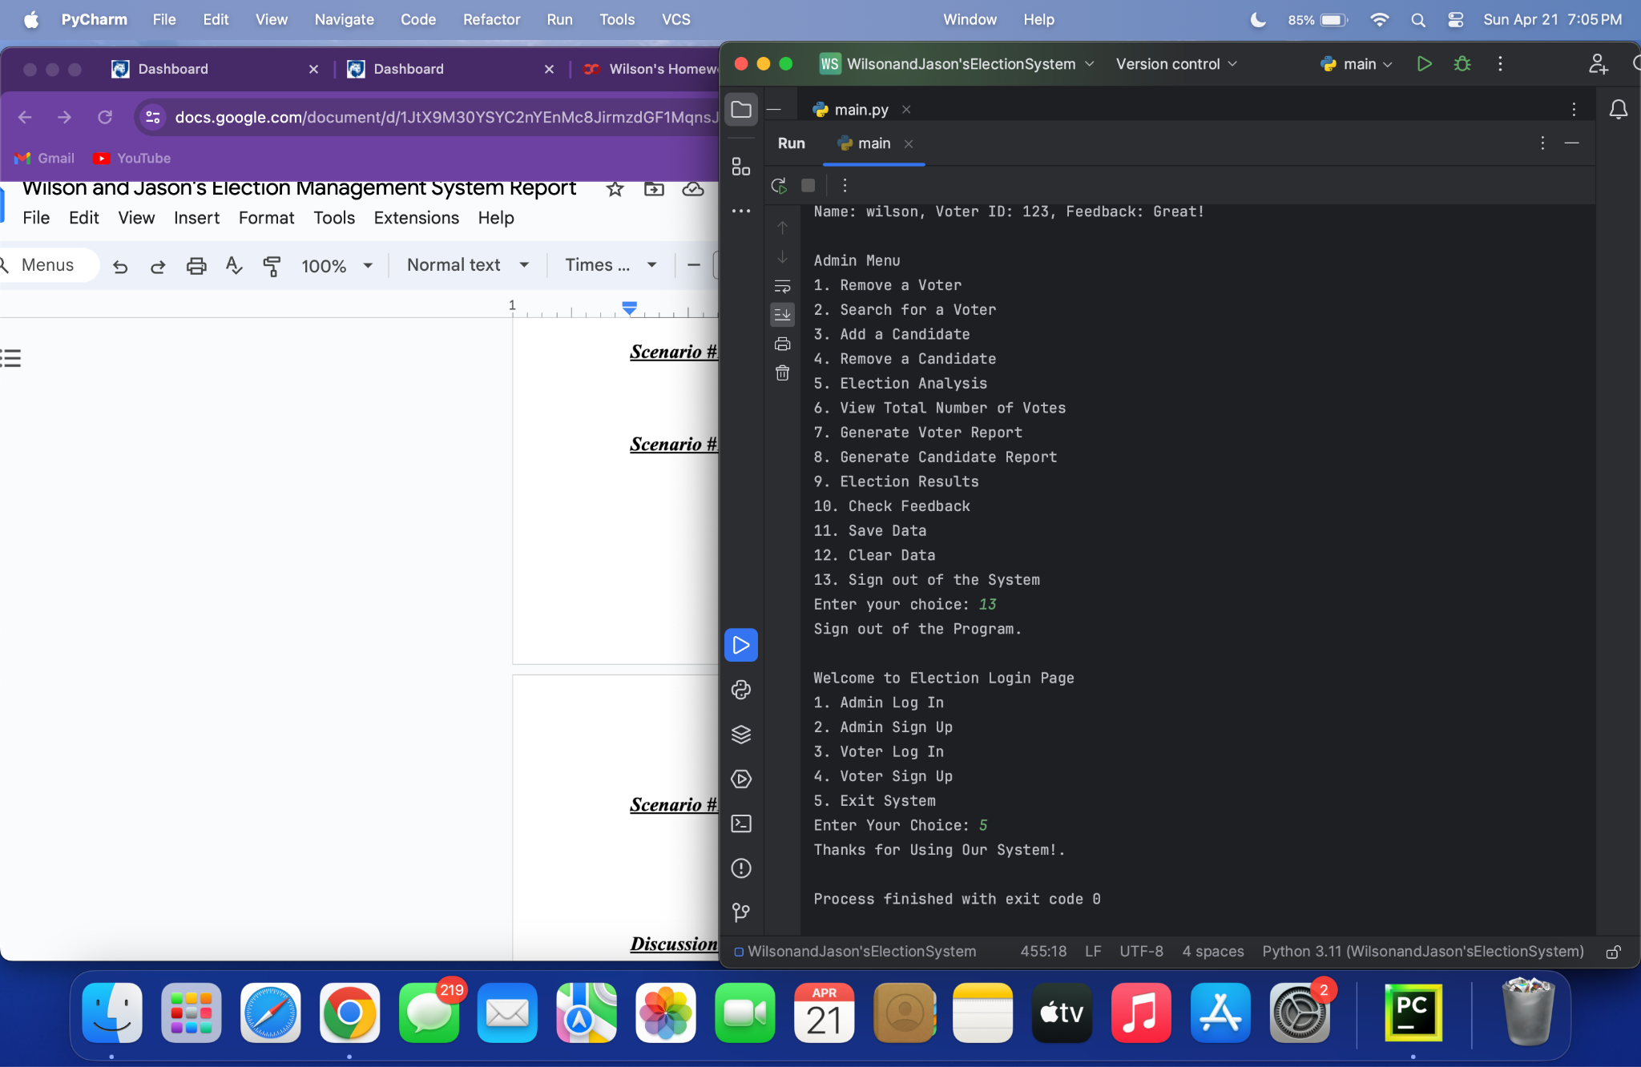

***Discussion:***

In developing our election management system, we encountered plenty of challenges, particularly security and data storage. Using CSV files for data storage, although it was straightforward, has shown its limits in scalability and security, which does show that it may be unsuitable for handling the data effectively. However, for this project, it was enough and works perfectly for what we have done. The system’s security was also a concern we ran into, as storing passwords in plaintext and somewhat lacking in authentication mechanisms that expose the system to unauthorized breaches. Additionally relying on linear searches for data retrieval could slow the performance as voter and candidate data volumes grow.

The project allowed us to apply key concepts that we had learned through the semester such as Object-Oriented Programming, which helped with the structuring of using classes like ‘Voter’, ‘Candidate’, ‘Admin’, and ‘Election’ for better scalability and readability of the code. However, we do recognize the limits of initial data management approaches and we were thinking of different possibilities for database systems. The identification of these flaws that we are highlighting are areas that can be built upon for future improvement, undermining the importance of secure coding and efficient algorithm implementation when developing reliable and user-friendly software systems. The installation for the program also caused an obstacle in a way for both us. We had to do research through Google and YouTube to figure out exactly how to make our program downaloadable for other people to use. After finding a solution on YouTube and Google, we managed to implement instructions on how to download our system as shown previously in our report.

***Areas for Improvement:***

Although our code does what it is supposed to do effectively and efficiently, there are areas that we could improve upon. First, we could transition from CSV file storage to using a database like SQLite which would drastically improve handling the data’s integrity and efficiency, which would mitigate issues that are associated with concurrency and scalability in the data. Additionally, adding more security measures, like blurring out or hashtagging passwords instead of them showing as plain text, can allow for safeguarding user information and enhancing the system’s integrity. We could have also optimized the command line interface by using libraries like ‘click’ which would enhance the user experience by making the interface more interactive and easier to use. Finally, the system could have benefitted from unit testing to make sure that each piece of the code functions correctly independently, which will reduce bugs and improve reliability during elections. These enhancements would overall enhance the system’s performance, security, and user engagement, to make it more user-friendly for admins and voters.

***Conclusions:***

In our Election Management System, we used many different methods and implemented many different functions we learned throughout our semester taking CMPSC 132 and from past semester experience in our CMPSC 131 class. We started with importing CSV Files, for our storage system We both have experience with CSV Files in the past, in making projects such as the Library Management System. We then, went on to create different classes to store certain objects in such as the Candidate Class, having attributes such as a political candidate’s, name, party, and goals as president. We learned about Object Oriented Program, throughout this entire course, and this is shown in all the classes throughout our system, encapsulating data. We also learned about Data Structures and Algorithms throughout the entire course, and this is shown in our project through methods like searching for a candidate in the system, and the program will go look for any stored candidates in the list. There are also multiple different data structures throughout the code such as Tuples and Lists. Overall, our Election Management System illustrates how to apply various programming techniques and methods, that we learned throughout both CMPSC 131 and CMPSC 132. These methods and techniques include things such as Object Oriented Programming, File Handling (CSV Files), Usage of Classes and Attributes in those Classes, Exception Handling (Try and Except), and allowing the user to input what they desire in the program and the action will be completed using these several different methods. In the end, our Election Management System serves as an easy-to-use system for all users, Admin or Voters, and it can be seen as an example of how all the concepts we’ve learned this past semester can be applied to create real-world applications and projects.

***Tests:***

* Test #1 - After creating all the code, we first tested out the admin menu and after committing an action it kept taking us back to the main menu, so we had to modify the admin_menu function so it doesn’t do that and instead keep you in the admin menu. Result: Fail
* Test #2 - The same thing happened with our voter menu, so we had to modify the voter_menu function so it doesn’t do that as well and keeps you in the voter menu. Result: Fail
* Test #3 - Testing out Both Admin login and Admin Sign Up. Result: Successful
* Test #4 - Registering a new voter. (Admin) Result: Successful
* Test #5 - Searching for a voter. (Admin) Result: Successful
* Test #6 - Removing a voter. (Admin) Result: Successful
* Test #7 - Adding a Candidate. (Admin) Result: Successful
* Test #8 - Generating Candidate Report. (Admin) Result: Successful
* Test #9 - Removing a Candidate. (Admin) Result: Successful
* Test #10 - Signing Up as a Voter. (Voter Sign Up) Result: Successful
* Test #11 - Now Logging in as a new voter. (Voter Log-In) Result: Successful
* Test #12 - Voting. (Voter) Result: Successful
* Test #13 - Searching Candidates. (Voter) Result: Successful
* Test #14 - Viewing Candidates Attributes. (Voter) Result: Successful
* Test #15 - Changing Vote. (Voter) Result: Successful
* Test #16 - Viewing Your Vote Status (Who you voted for) Result: Successful
* Test #17 - Feedback (Voter) Result: Successful
* Test #18 - Election Analysis (Admin) Result: Fail, it’s just printing out the winner of the election, not who voted for whom.
* Test #19 - Fixing Election Analysis (Admin) Result: Successful. In the Admin menu I had it set to print out Election Results and the Winner, so I changed it to call the election analysis function.
* Test #20 - The final Test on the System was Successful, as everything functions the way it’s meant to.